CREATE TABLE Student1 (St_ID int(1),Name varchar(20),Address varchar(20),Phone int(4);

CREATE TABLE course1 (Course_ID varchar(7),St_id int(2));

INSERT INTO student1 VALUES(1,'Ab','Dhaka',1234);

INSERT INTO student1 VALUES(2,'Ac','Shylet',1123);

INSERT INTO student1 VALUES(3,'Ad','Rangpur',1235);

INSERT INTO student1 VALUES(4,'Ae','Siraganj',2345);

INSERT INTO student1 VALUES(5,'Af','Pabna',3456);

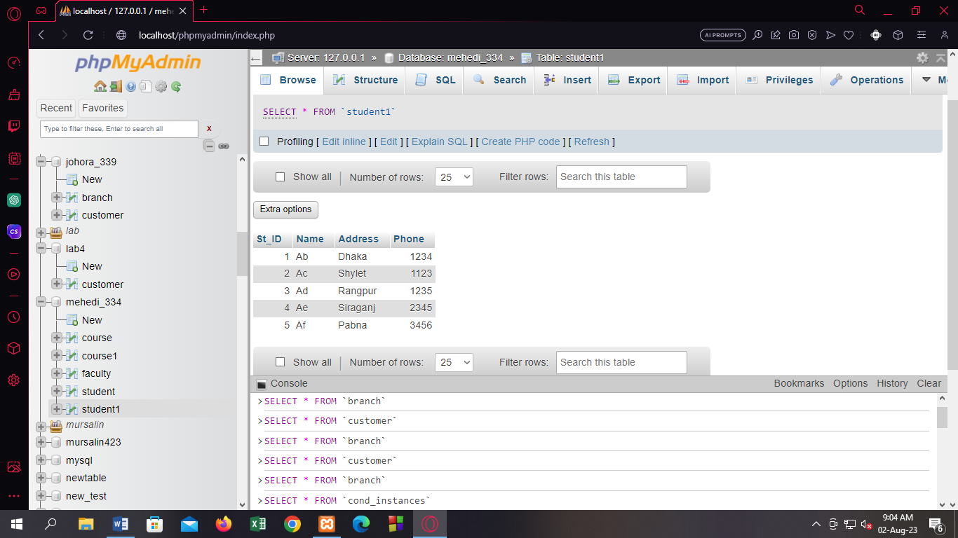

INSERT INTO course1 VALUES('CSE 207',1);

INSERT INTO course1 VALUES('CSE 208',2);

INSERT INTO course1 VALUES('CSE 209',3);

INSERT INTO course1 VALUES('CSE 309',7);

INSERT INTO course1 VALUES('CSE 111',8);

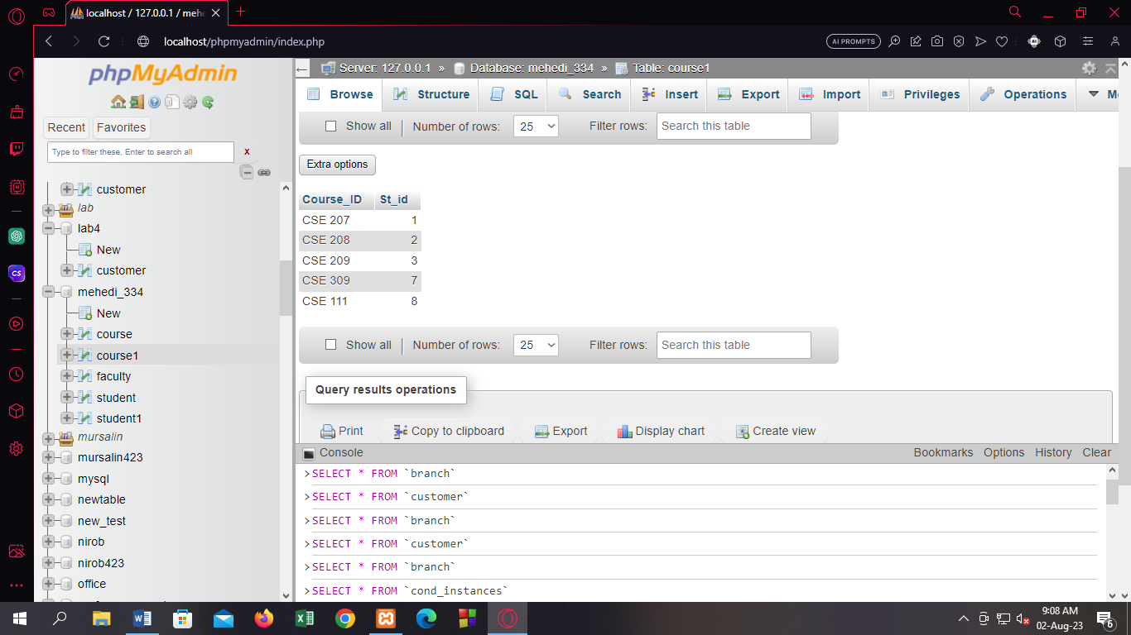

**Start**

Q1. Find the total number of courses from the “Course” table.

ANS:

SELECT COUNT(Course_ID)"total number of courses" FROM course1;

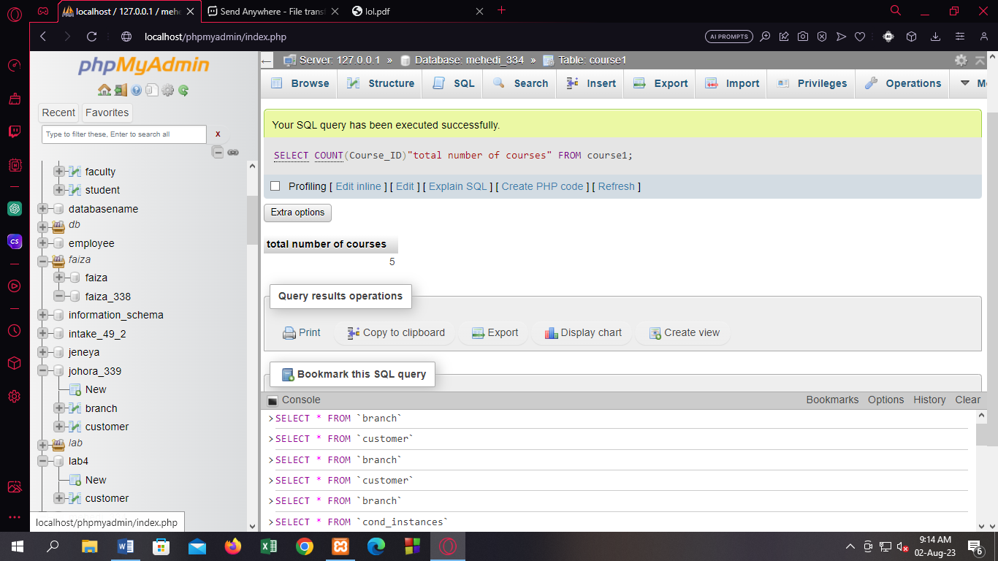

Q2. Add a new column named “Age”.

Query:

ALTER TABLE student1 ADD COLUMN Age int(2);

Q3. Insert the corresponding Values for this column.

Query:

UPDATE student1 SET Age=20 WHERE St_ID=1;

UPDATE student1 SET Age=21 WHERE St_ID=2;

UPDATE student1 SET Age=23 WHERE St_ID=3;

UPDATE student1 SET Age=22 WHERE St_ID=4;

UPDATE student1 SET Age=22 WHERE St_ID=5;

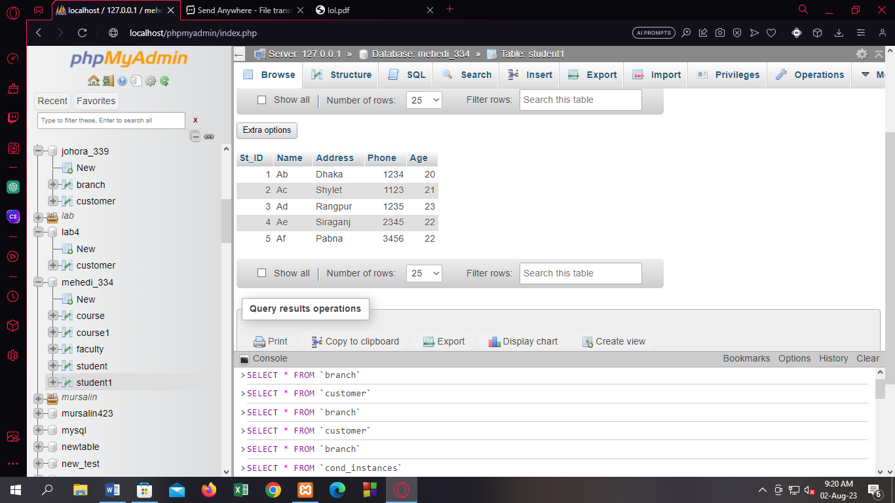

Q4. Find the names of those students whose age is between 21 and 23.

Query:

SELECT Name FROM student1 WHERE Age>=21 AND Age<=23;

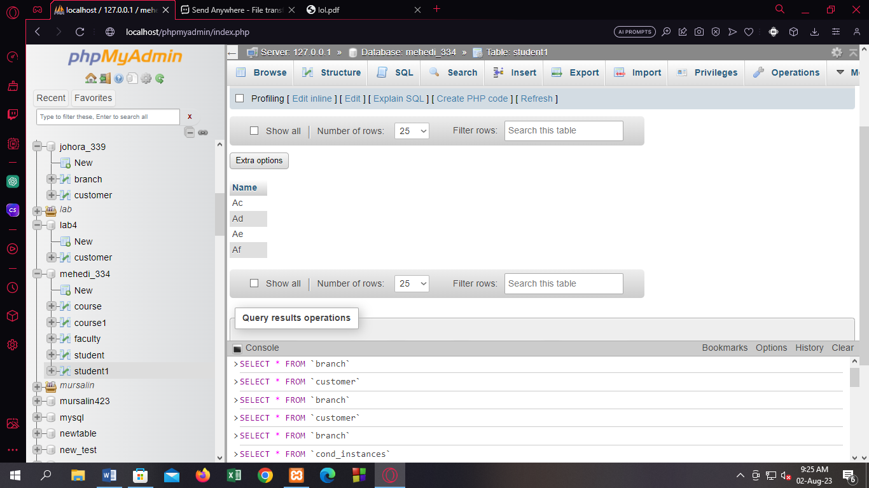

Q5. Find the ID of those students who have taken either CSE 207 or CSE 309.

Query:

SELECT St_id FROM course1 WHERE Course_ID="CSE 207" OR Course_ID="CSE 309";

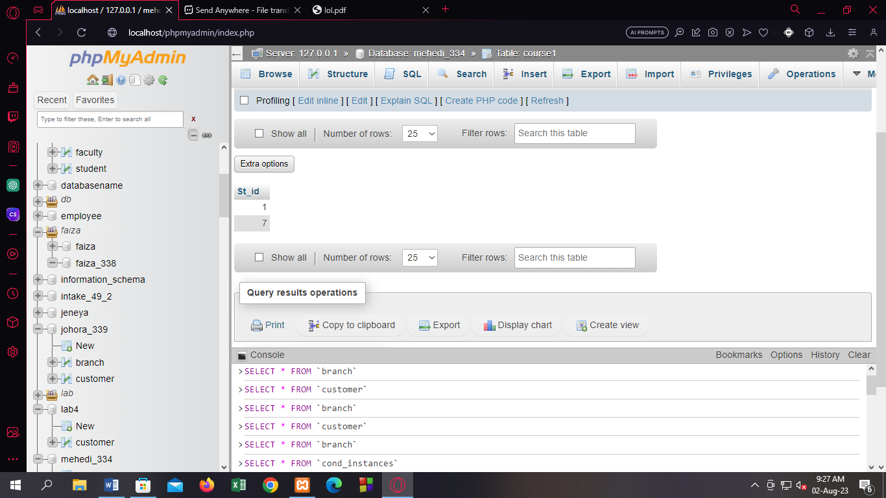

Q6. Find the name of the student with the highest age.

Query:

[SELECT](http://localhost/phpmyadmin/url.php?url=https://dev.mysql.com/doc/refman/8.0/en/select.html) Name FROM student1 WHERE Age=([SELECT](http://localhost/phpmyadmin/url.php?url=https://dev.mysql.com/doc/refman/8.0/en/select.html) [MAX](http://localhost/phpmyadmin/url.php?url=https://dev.mysql.com/doc/refman/8.0/en/aggregate-functions.html%23function_max)(Age) FROM student1);

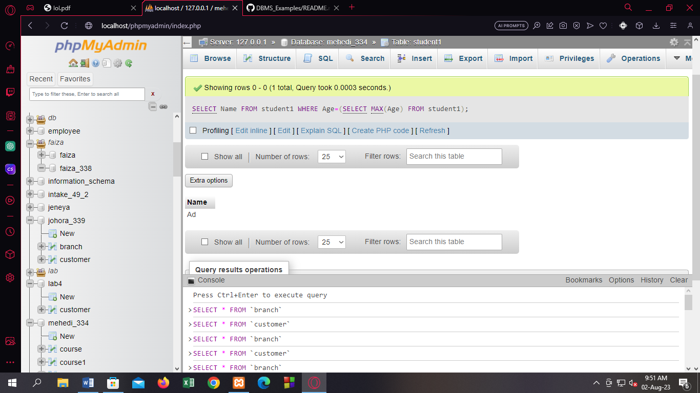

[SELECT](http://localhost/phpmyadmin/url.php?url=https://dev.mysql.com/doc/refman/8.0/en/select.html) Name,Age FROM student1 WHERE Age=([SELECT](http://localhost/phpmyadmin/url.php?url=https://dev.mysql.com/doc/refman/8.0/en/select.html) [MAX](http://localhost/phpmyadmin/url.php?url=https://dev.mysql.com/doc/refman/8.0/en/aggregate-functions.html%23function_max)(Age) FROM student1);

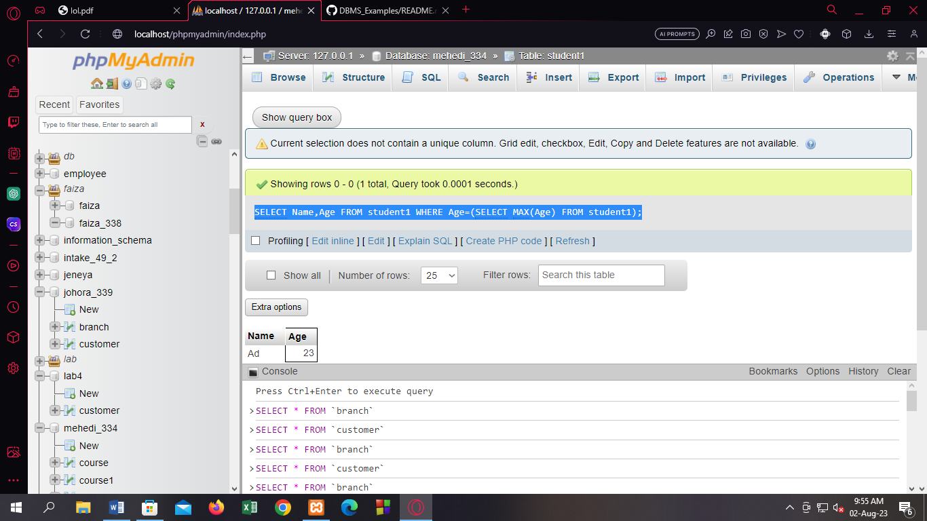

Q7. Find the total number of students (column name should be “Total number of students”).

Query:

SELECT COUNT(St_ID)"Total number of students" FROM student1;

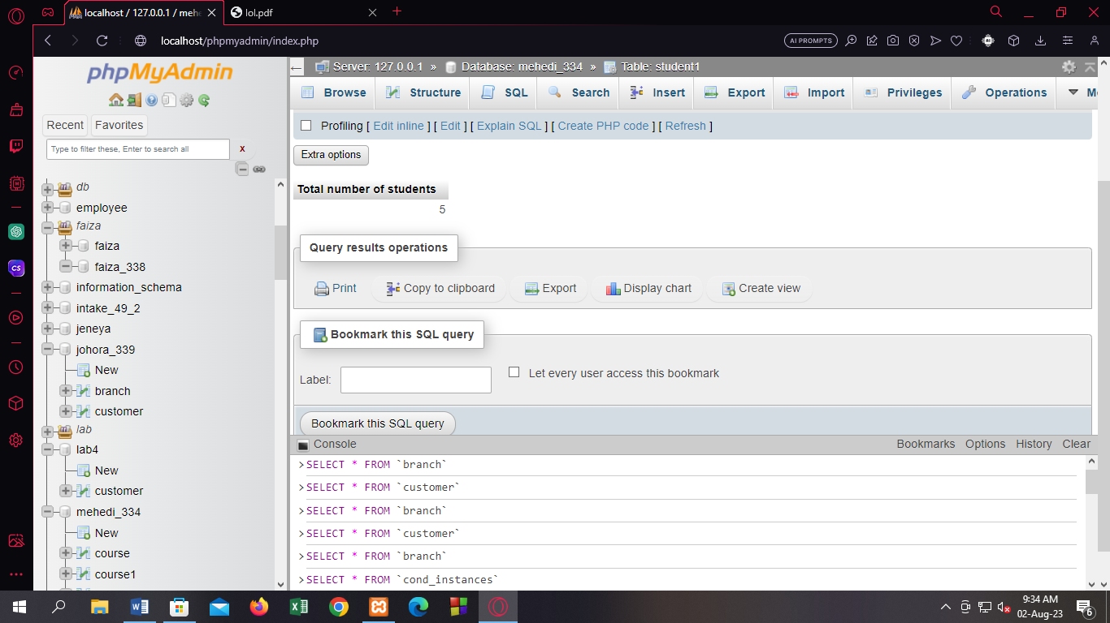

Q8. Rearrange the age of the students in descending order.

Query:

SELECT Age FROM student1 ORDER BY Age DESC;

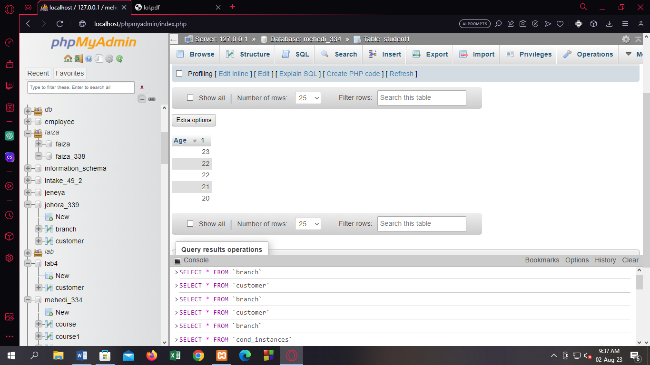

Q9. Find the name of those students whose address starts with S.

Query:

SELECT Name FROM student1 WHERE Address LIKE"S%";

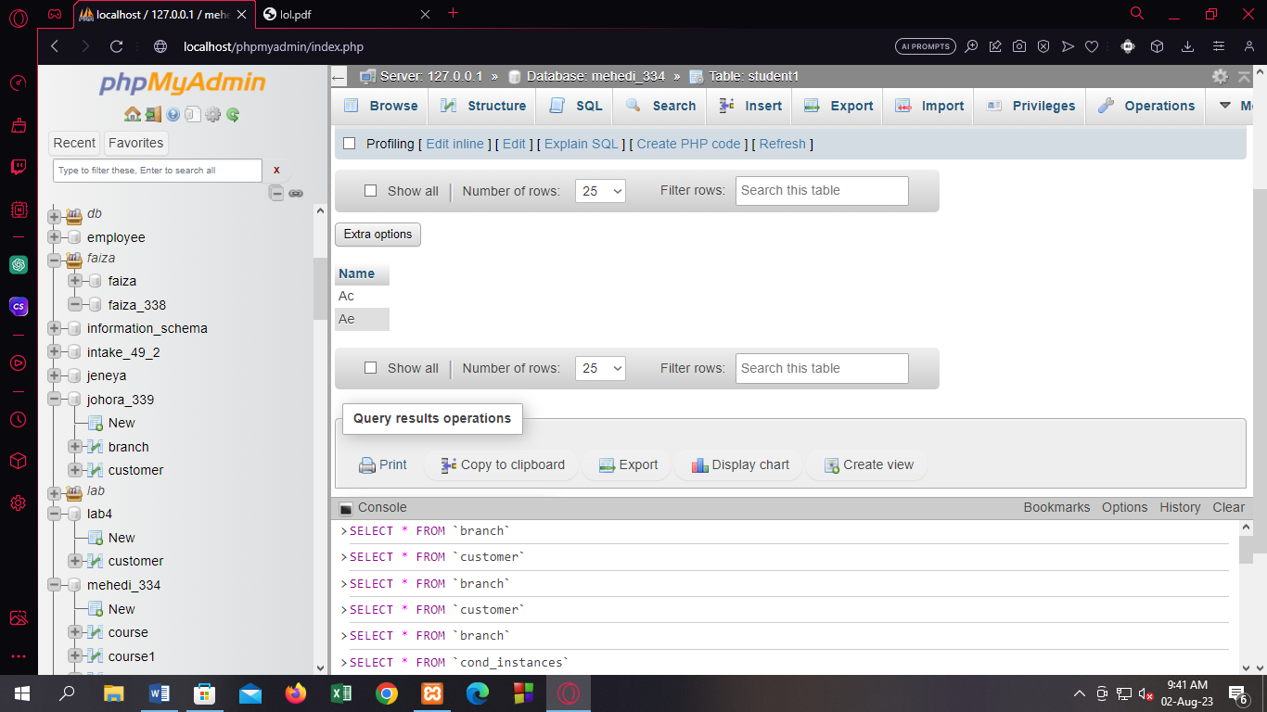

Add Nid after address

ALTER TABLE student1 ADD COLUMN NID int(5) AFTER Address;

